hariprabha p  hariprabha.sp@gmail.com  Contact No  00919447794635  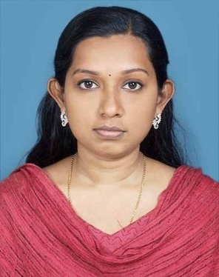  Permanent Address  Manthattil  Kanakkary P O  Kottayam 686 632  Personal Information  Age 24  D-O-B 31-01-1987  Gender Female  Civil Status Single  Nationality Indian  Father’s Name M S Prasannan  Mother’s Name K L Sreedevi  PERSONAL SKILLS:  Ability to deal with people diplomatically, willingness to learn and a good team player.  Hobbies:  - Listening to Music  - Glass Painting | Objective:  ➢ To attain the goals in my life by facing all challenges with a positive attitude and thereby bring pride to the organization. I aspire to associate myself with a dynamic growing organization in pursuit to learn as well as to contribute the best of my knowledge, skill and ability.  Academic Profile:  ➢ Master of Business Administration (6.57)  School of Management Studies,  Cochin University of Science And Technology.  ➢ B.Sc. Electronics with Computer Hardware (59%)  IHRD, College of Applied Science, Kottayam,  Mahatma Gandhi University.  ➢ XII (66%)  Govt. Higher Secondary School, Kanakkary,  Board of Higher Secondary Examination, Kerala.  ➢ X (86%)  Govt. Vocational Higher Secondary School, Kanakkary,  Board of Public Examination, Kerala.  AREA OF INTEREST:  - Human Resource Management  - Marketing.  ACHIEVEMENTS:  - Elected as Lady Representative during 2005-2006  - Rashtrapathy Guide  - Elected as the representative of Rashtrapathy guides from Pala Educational District for receiving the Award from the President of India.  ACADEMIC PROJECTS:  - ‘Talking Multimeter’  - Organization Study at Mangalam Publications, Kottayam  - ‘Quality of Work Life’ at Asianet Satellite Communications Pvt Ltd, Trivandrum.  Personal Traits:  As I believe hard work is the key to success and character to personality, I always keep myself proactive.  DECLARATION:  I, Hariprabha P, do hereby declare that the particulars of information and facts stated here in above are true, correct and complete to the best of my knowledge and belief.  Place : Kottayam  Date : 06/04/2011  (Hariprabha P.)

